2.1 GENERATION AND ANALYSIS OF FREQUENCY MODULATED (FM) SIGNALS USING MATLAB
Objective 1:
To generate a Frequency Modulated (FM) signal using MATLAB by varying the frequency of a high-frequency carrier in accordance with the amplitude of the message signal and to observe the resulting waveform in the time domain.
PROGRAM (MATLAB CODE)
clc;
clear;
close all;
Am=1;
Ac=1;
fm=5;
fc=50;
beta=5;
kp=5;
fs=1000;
t=0:1/fs:1;
m = Am*cos(2*pi*fm*t); % Message signal
c = Ac*cos(2*pi*fc*t); % Carrier signal
fm_sig = Ac*cos(2*pi*fc*t + beta*sin(2*pi*fm*t)); % FM
subplot(4,1,1), plot(t,m), title('Message Signal')
subplot(4,1,2), plot(t,c), title('Carrier Signal')
subplot(4,1,3), plot(t,fm_sig), title('FM Signal')
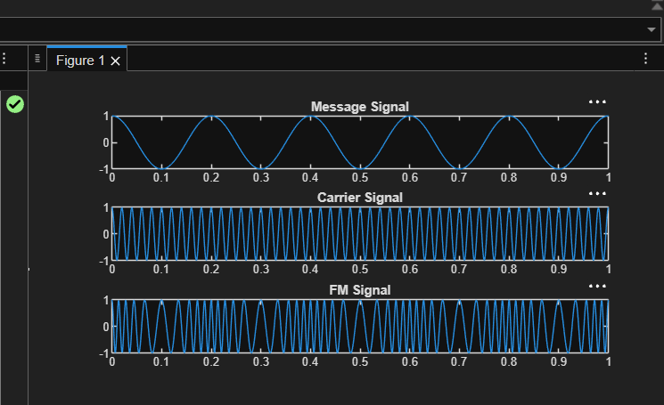

Objective 2:
To analyze the frequency spectrum of the generated FM signal using FFT and identify the carrier component, sideband frequencies, and the bandwidth of the FM signal based on Carson's rule
PROGRAM (MATLAB CODE)
clc;
clear;
close all;
%% Input Parameters
Am = 2; % Message signal amplitude
fm = 500; % Message frequency (Hz)
Ac = 1; % Carrier amplitude
fc = 10000; % Carrier frequency (Hz)
kf = 1000; % Frequency sensitivity (Hz/V)
fs = 100000; % Sampling frequency (Hz)
T = 0.02; % Simulation duration (s)
t = 0:1/fs:T;
%% Message Signal
m = Am*cos(2*pi*fm*t);
%% Frequency Deviation Calculation
delta_f = kf * Am;
%% Modulation Index Calculation
beta = delta_f/fm;
%% FM Signal Generation
fm_signal = Ac*cos(2*pi*fc*t + beta*sin(2*pi*fm*t));
%% Plot Message Signal
figure;
subplot(2,1,1);
plot(t,m,'LineWidth',1.5);
title('Message Signal');
xlabel('Time (s)');
ylabel('Amplitude');
grid on;
%% Plot FM Signal
subplot(2,1,2);
plot(t,fm_signal,'LineWidth',1.5);
title('Frequency Modulated Signal');
xlabel('Time (s)');
ylabel('Amplitude');
grid on;
%% Spectrum Analysis
N = length(fm_signal);
FM_fft = fftshift(abs(fft(fm_signal))/N);
f = (-N/2:N/2-1)*(fs/N);
figure;
plot(f,FM_fft,'LineWidth',1.5);
title('FM Signal Spectrum');
xlabel('Frequency (Hz)');
ylabel('Magnitude');
grid on;
xlim([fc-10000 fc+10000]);
%% Display Results

fprintf('\nFM SIGNAL PARAMETERS\n');
fprintf('---------------------------\n');
fprintf('Carrier Frequency = %.0f Hz\n',fc);
fprintf('Message Frequency = %.0f Hz\n',fm);
fprintf('Message Amplitude = %.2f V\n',Am);
fprintf('Frequency Sensitivity = %.0f Hz/V\n',kf);
fprintf('\nCALCULATED VALUES\n');
fprintf('---------------------------\n');
fprintf('Frequency Deviation (Δf) = %.0f Hz\n',delta_f);
fprintf('Modulation Index (β) = %.2f\n',beta);
%% Carson's Rule Bandwidth
BW = 2*(delta_f + fm);
fprintf('Bandwidth (Carson Rule) = %.0f Hz\n',BW);
